Specialized Kazakh-school gymnasium named after Abai
Lesson plan
Theme of the lesson :Celebrations
Unit :3 | Title:Family and friends
Teacher’s name | Arstan Symbat Berikovna
Date: | 29.11.2023
Grade:5 | Number present: Numbers absent:
Learning objectives: | 5.2.6.1 identify with support the meaning from the context of a short conversation on some general and educational topics  5.3.3.1 to express an opinion at the proposal level within the framework of some general and educational topics;
Lesson objectives | -define types of holidays  -recognize wide information such as decoration and character of celebrations about holidays
Stage | Teacher’s activity | Student’s activity | Assessment | Resources
Beginning of the lesson  (4min) | Greeting  T; Good morning everyone!  How are you today?  Guys , I want you to clap to each other and wish something good!  Well done! I also have good wishes to you. There are sweets with warm wishes | Students greet the teacher and each other | Well done!  I am proud of you, guys, take your sweets | 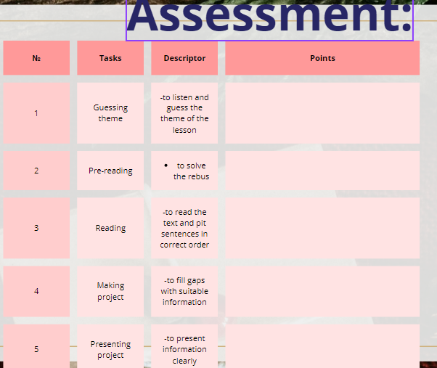
Lead-in  (7 min) | Guys, can you tell me , do you like to watch you tube bloggers?  Can you name me some of them  I want to show you a blogger who isn’t famous buy anyway you know her!  Let’s look at the whiteboard!  Who is that blogger?  What does she tell us about?  What will talk about at today’s lesson?  Can you name what kind of celebrations will we talk about? | It is you. Today we will talk about celebrations.  New Year | Correct ! You are right  1.New year  2.Nauryz  3.Birthday  4. Women’s day | Video
Middle  5 min  3 min  5min  5 min  8 min  Ending  5-7 min | Pre-reading:  «Rebus»  4 groups will guess 4 different holidays  Aim: to improve students interest before reading and encourage all students to group work  Next part  While other students are reading the text I want to  Akniet,Saniya,Ernar and Sabina to come to the blackboard and say what are these decorations and for which celebrations are they used?  Now it’s high time to read the text  I give you mixed parts of the text you need to put the paragraphs into correct order.  Post-reading:  Students if you look at the whiteboard you can see QR-code scan it and complete the task in wordwall platform , some tasks, first is to decide whether statements are true or are they false and second is to read the sentences and say which celebration is described in the sentence.  Now we are moving to last and the most creative task of today’s lesson. You need to make a ledbook of your celebration and fill it with suitable information.  Reflection  I hope you enjoyed our lesson ! This is the Sun but it filled with clouds we need to answer on the question and make the Sun shine. | 1st group:  New year  2nd group :Nayruz  3rd group:  Birthday  4th group:  Women’s day  Candy cane  Flower  Birthday hat  Jacket  Identify true and false statements | Well done! You are so clever you guessed everything correct\  Thank you guys, you are right | Canva presentation  Slide-1  Pictures  Slide-2  Texts  Slide-3  Worwall QR-code  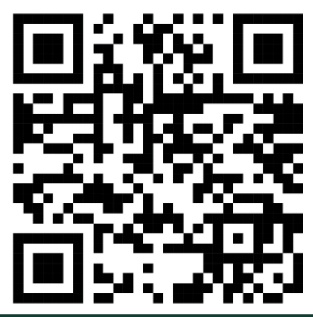
  Descriptor
  1.put the paraghraphs into correct
  order
  Descriptor
  1.fill in with correct information
  2. present it to the class

Dividing into groups:
Slide-1

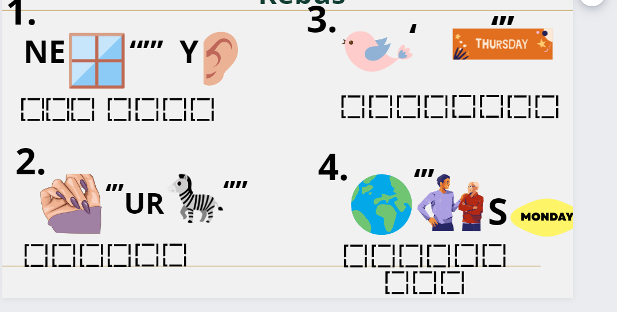

Naming the theme of group in accordance with group:
Slide-2
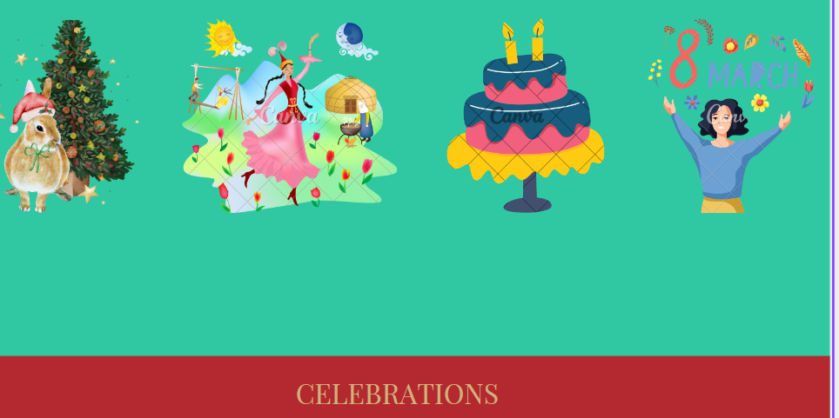

Reading time:
Slide-3
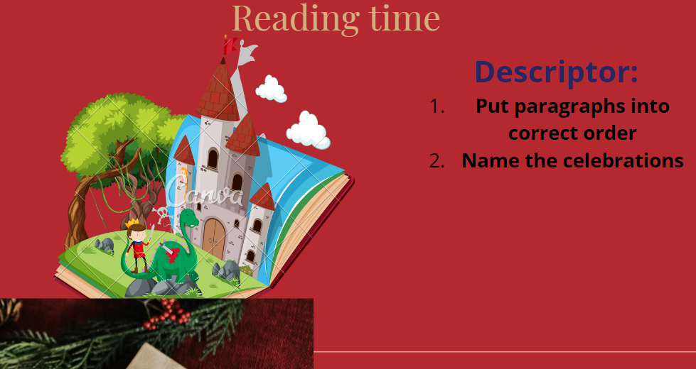

Once upon a time lived girl whose name was Leila. She liked different celebrations. For example, New Year , Nauryz , Birthday and women’s day . New Year is one of the family holidays. She celebrates the New Year with her family and parents. They celebrate New year on December 31st . They decorate the Christmas tree with tinsel , garlands , balloons and toys . Every year Santa Claus and Snow Maiden come to Leila . Santa Claus gives her dolls, cars and toys.
Next celebration is Nauryz . Nauryz is celebrated on the 22nd of March . Leila likes Nauryz. Kazakh people dances Kara zhorga, sing songs and , cooks bauyrsaks. Also her mom makes kymyz. Our city is decorated with yurts , horses and flowers. They wear national dresses .
One of the best spring’s holidays is women’s day . We celebrate it on the 8th of March . We respect girls, moms ,women and grandmas . We give presents like flowers , cards and chocolates. School students sing songs ,draw pictures , dance and say poems to their moms .
Also Leila likes her birthday party. She celebrates it on the 3rd of August. She gets up early and her house is decorated with balloons and toys . She wears beautiful dress and birthday hat . Leila gets presents like flowers , toys, cards. Her mom makes a cake . Everyone sings happy birthday song.Leila wishes you to have a lot of celebrations.

QR-code:
Slide-4
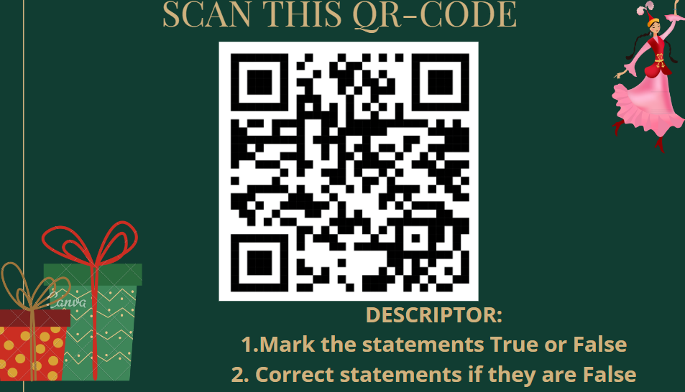
Slide-5
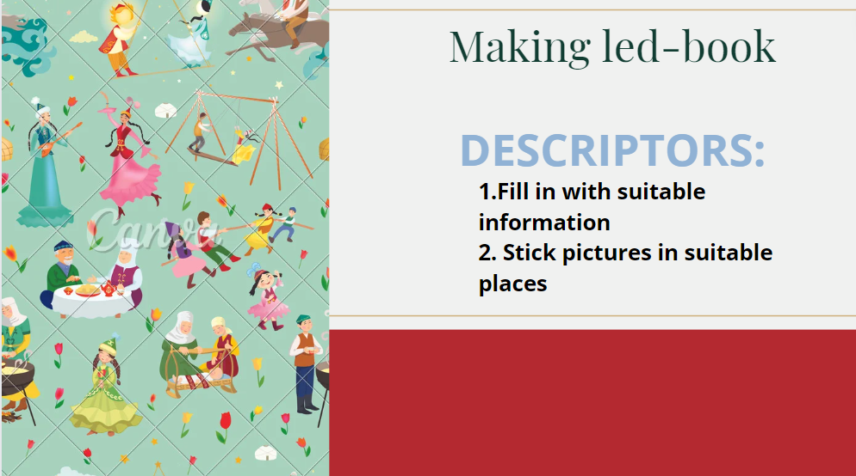

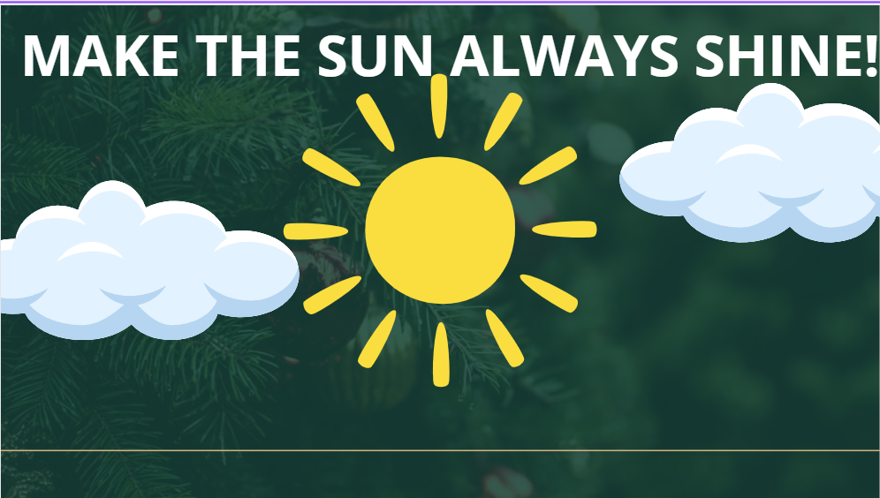

Answering on the question from each part of the Sun

