Open lesson

Unit 5: Art and Music
Teacher name: |  | Zhumalina A
Date: |  | 13/02/24
Grade: 3 |  | Number present: | absent:
Lesson title | Shadow puppet show
Learning objectives | 3.4.6.1 correctly use uppercase and lowercase letters when writing names, place names and short sentences when doing written work in class under the guidance of a teacher;  3.5.12.1 use adverbs of time and frequency: sometimes, often, always, never to indicate when and how of
Lesson objectives | Learners will be able to:  - to consolidate the language of the module
Value links | Self-Discipline – If you value self-discipline, you might be a person who wakes up early, exercises daily, and doesn’t get distracted by vices.
Plan

Stages / Time | Teachers actions | Students actions | Assessment criteria | Resources
Beginning of the lesson  Warming-up    3 min  Pre-learning  «Brainstorming» method  7 min. | Organization moment :  1.Greeting.  Ask about the weather.  The teacher sets the lesson objectives, letting students know what to anticipate from the lesson.  Warming up  Where are you from?  How old are you?  What color is it?  How many students are there in class?  What day of the week today?  Lead – In  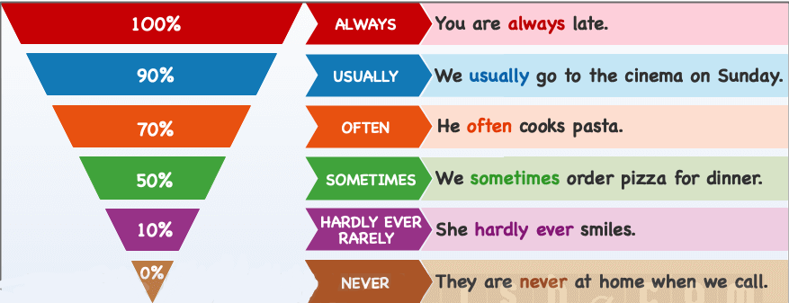 | “The wish lamp” method helps to start the lesson with good wishes to each other.  The aim: To develop pupils speaking skills and create friendly atmosphere  Efficiency: By wishing each other they feel better and feel the support of others  Students of the class are listed.  Students' attention is drawn to the lesson.  • Learners talk about rooms previous lesson vocabulary  Determines the topic and purpose of the lesson  Students say different words from the picture | The teacher to assess learners for their ability.  “Good job!  Well done!”  Formative Assessment    Good job!  Descriptor:  -know key phrases  - can make sentence  - know vocabulary of previous lesson  Total: 1 point  Assessment criteria  - Learners have met the learning objectives if they can: Talk about | Pictures  worksheet  Student’s book
Middle of the lesson  Presentation part.  30 min | Ex:3 P:77  • The pupils read the questions and answer orally or in writing in their notebooks  Ex: 4 P: 77  • Explain the activity. Allow the pupils some time to look at the words and put them in the correct order to make complete sentences. Check their answers.  Ex: 5 P: 77  • Explain the activity. Allow the pupils time to read the text and fill in the missing words. Check their answers.  Conclusion during the lesson some tasks differentiated by outcomes of the students and by their abilities. | Scene 1  There is a little house in the forest. A mouse (Амина) runs by:  Mouse:-  «Knock, knock, knock! Little house, little house! Who lives in the little house?». Nobody answers. «Ooooh, I can live there»  So the mouse begins to live in the little house.  Scene 2  A rabbit runs by:  Rabbit:  Rabbit: «Knock, knock, knock! Little house, little house, who lives in the little house?»  Mouse: «I’m a mouse. And who are you?»  Rabbit: «I’m a frog.»  Mouse: «Let’s live together!»  Rabbit: «OK»  Teacher:  So the mouse and the rabbit begin to live together.  Scene 3  A cat runs by:  Cat: «Knock, knock, knock! Little house, little house, who lives in the little house?»  Mouse: «I’m a mouse»  Rabbit: «I’m a rabbit. And who are you?»  Cat: «I’m a cat.»  Animals: « Let’s live with us»  Teacher:  So the mouse, the rabbit and the cat begin to live together.  Scene 4  A cock runs by:  Cock: «Knock, knock, knock! Little house, little house, who lives in the little house?»  Mouse: «I’m a mouse»  Cat: «I’m a cat.»  Rabbit: «I’m a rabbit. And who are you?»  Animals: « Let’s live with us»  Teacher:  So the mouse, the rabbit, the cat and the cock begin to live together.  Scene 5  A fox runs by:  Fox: «Knock, knock, knock! Little house, little house, who lives in the little house?»  Mouse: «I’m a mouse»  Cat: «I’m a cat.»  Rabbit: «I’m a rabbit. »  Cock: “I’m a cock. And who are you?”  Fox: “I’m a fox”  Animals: « Let’s live with us»  Teacher  So the mouse, the rabbit, the cock the cat and the fox begin to live together.  Scene 6  A turkey runs by:  Turkey:« Knock, knock, knock! Little house, little house, who lives in the little house?»  Mouse: «I’m a mouse»  Cat: «I’m a cat.»  Rabbit: «I’m a rabbit. »  Cock: “I’m a cock.”  Fox: “I’m a fox. And who are you?”  Turkey: “I’m a turkey”  Animals: « Let’s live with us»  Teacher  So the mouse, the rabbit, the cock the cat, the turkey and the fox begin to live together.  Scene 7  A duck runs by:  Duck: «Knock, knock, knock! Little house, little house, who lives in the little house?»  Mouse: «I’m a mouse»  Cat: «I’m a cat.»  Rabbit: «I’m a rabbit. »  Cock: “I’m a cock.”  Fox: “I’m a fox.”  Turkey: “I’m a turkey. And who are you?”  Duck: “I’m a duck”  Animals: « Let’s live with us»  Teacher  So the mouse, the rabbit, the cock, the cat, the turkey, the fox and duck begin to live together.  Scene 8  A dog runs by:  Dog: «Knock, knock, knock! Little house, little house, who lives in the little house?»  Mouse: «I’m a mouse»  Cat: «I’m a cat.»  Rabbit: «I’m a rabbit. »  Cock: “I’m a cock.”  Fox: “I’m a fox.”  Turkey: “I’m a turkey.”  Duck: “I’m a duck. And who are you?”  Dog: “I’m a dog”  Animals: « Let’s live with us»  Teacher  So the mouse, the rabbit, the cock, the cat, the turkey, the fox,the duck and the dog begin to live together.  Scene 9  A pig runs by:  Pig: «Knock, knock, knock! Little house, little house, who lives in the little house?»  Mouse: «I’m a mouse»  Cat: «I’m a cat.»  Rabbit: «I’m a rabbit. »  Cock: “I’m a cock.”  Fox: “I’m a fox.”  Turkey: “I’m a turkey.”  Duck: “I’m a duck. ”  Dog: “I’m a dog. And who are you?”  Pig: “I’m a pig”  Animals: « Let’s live with us»  Teacher  So the mouse, the rabbit, the cock, the cat, the turkey, the fox,the duck, the dog and the pig begin to live together.  Scene 10  A sheep runs by:  Sheep: «Knock, knock, knock! Little house, little house, who lives in the little house?»  Mouse: «I’m a mouse»  Cat: «I’m a cat.»  Rabbit: «I’m a rabbit. »  Cock: “I’m a cock.”  Fox: “I’m a fox.”  Turkey: “I’m a turkey.”  Duck: “I’m a duck. ”  Dog: “I’m a dog.”  Pig: “I’m a pig. And who are you?”  Sheep: “I’m a sheep”  Animals: « Let’s live with us»  Teacher  So the mouse, the rabbit, the cock, the cat, the turkey, the fox,the duck, the dog, the pig and the sheep begin to live together.  Scene 11  A raccoon runs by:  Raccoon: «Knock, knock, knock! Little house, little house, who lives in the little house?»  Mouse: «I’m a mouse»  Cat: «I’m a cat.»  Rabbit: «I’m a rabbit. »  Cock: “I’m a cock.”  Fox: “I’m a fox.”  Turkey: “I’m a turkey.”  Duck: “I’m a duck. ”  Dog: “I’m a dog.”  Pig: “I’m a pig.”  Sheep: “I’m a sheep . And who are you?”  Animals: « Let’s live with us»  Teacher  So the mouse, the rabbit, the cock, the cat, the turkey, the fox,the duck, the dog, the pig, the sheep and the raccoon begin to live together.  Scene 12  A bull and a horse runs by:  Bull: «Knock, knock, knock! Little house, little house,”  Horse: who lives in the little house?»  Mouse: «I’m a mouse»  Cat: «I’m a cat.»  Rabbit: «I’m a rabbit. »  Cock: “I’m a cock.”  Fox: “I’m a fox.”  Turkey: “I’m a turkey.”  Duck: “I’m a duck. ”  Dog: “I’m a dog.”  Pig: “I’m a pig.”  Sheep: “I’m a sheep . And who are you?”  Bull: “I’m a bull”  Horse: “I’m a horse. Let’s live together”  Animals: «No! You’re too big. You can’t live in our little house!»  Bull and horse: “Yes, we can”  Animals: «No! You can’t »  Bull and horse: “Yes, we can”  Teacher: So, the horse and the bull climbed into the house, but the house did not break, so the animals decided to live together.  That's the end of the good fairy tale  The end)  Pupils read and answer.  ANSWERS  1 Yes, it is.  2 I like reading comics.  3 I get up at half past seven.  4 The guitar.  Pupils make sentences.  ANSWERS  1 I always go shopping with my mum.  2 I never go to bed late. 3 They sometimes read a book.  4 He sometimes goes to the gym.  5 Do you always watch TV at night?  Pupils complete the sentences  ANSWERS  1 walk  2 homework  3 park  4 dinner  5 bed | Descriptor:  - read the questions  - answer orally or in writing in their notebooks  Total: 2 point  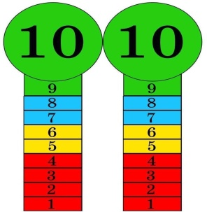  Self Assessment  Descriptor:  - look at the words  - put them in the correct order  Total: 2 point  Descriptor:  - complete the sentences  Total: 2 point  -Make CCQ questions Yes / No  Total: 10 point |   Card  Worksheet  Students book

