Specialized Kazakh school-gymnasium named after Abai

Lesson plan

Theme of the lesson: Natural reserves around the world

Unit 6: |  | The natural world
Teacher name: |  | Kushchugulova Laura Shalqarqyzy
Date: |  | 09.02.2024
Grade: 8 |  | Number present: | absent:
Lesson title | Natural reserves around the world
Learning objectives | 8.1.6.1 organise and present information clearly to others  8.3.7.1 use appropriate subject-specific vocabulary and syntax to talk about a range of general topics, and some curricular topics
Lesson objectives | Learners will be able to:  - To introduce the topic, to predict the content of the text, to listen for specific information
Value links | Integrity – Integrity is the quality of having strong moral principles. So, a person with integrity will always act with honesty and adhere to their own moral code regardless of what others do.
Plan

Stages / Time | Teachers actions | Students actions | Assessment criteria | Resources
Beginning of the lesson  Warming-up    3 min  Pre-learning  «Brainstorming» method  7 min. | Organization moment :  1.Greeting.  Ask about the weather.  The teacher sets the lesson objectives, letting students know what to anticipate from the lesson.  Warming up  How many students are there in class?  What day of the week today?  Revise the language of the previous lesson.  Teacher divide 2 groups using cards.  Lead – In   | The aim: To develop pupils speaking skills and create friendly atmosphere  Efficiency: By wishing each other they feel better and feel the support of others  Students of the class are listed.  Students' attention is drawn to the lesson.  Students are dividing 2 groups using cards.  • Learners write the numbers from previous lesson  Determines the topic and purpose of the lesson  Students say different words from the picture | The teacher to assess learners for their ability.  “Good job!  Well done!”  Formative Assessment    Good job!  Descriptor:  -know key phrases  - can make sentence  - know vocabulary of previous lesson  Total: 1 point=1 coins  Assessment criteria  - Learners have met the learning objectives if they can: To talk about places of nature beauty | Pictures  cards  slides  worksheet  Student’s book
Middle of the lesson  Presentation part.  30 min | consolidation of learned words 6a-d module words with method of Tarsia  Ex:1 P:71  • Ask Ss to read the introduction and look at the pictures.  • Ask Ss to guess which of the plants and animals can be found in each place.  -read the new and give the game «who am I»  • Play the recording. Ss listen and find out.  Teacher give the text with method Jigsaw  Ex: 2 a P: 71  • Read the sentences aloud one at a time and ask Ss to read the texts again and correct them.  Ex: 2b P: 71  • Give Ss time to read the texts again and find the words.  • Check Ss’ answers.  Ex: 3 P: 71  • Ask Ss to work in pairs and ask and answer questions about the two nature reserves.  • Monitor the activity around the class.  Conclusion during the lesson some tasks differentiated by outcomes of the students and by their abilities.  Teacher is counting coins and congrates both teams. | Consolidation of learned words 6a-d module words with method of Tarsia  Pupils read the introduction on the webpage and look at the picture. Answer the question.  -repeat the new words after the teacher and learn them during the game «who am I»  ANSWERS  Loch Lomond – bluebells, ransoms, red deer, red squirrels, wallabies Korgalzhyn Nature Reserve – roe deer, lynx, elk, moss, lichen, mushrooms, flamingos  Pupils read the text with method Jigsaw and correct the statements  ANSWERS  1 In the spring, the forests around Loch Lomond are full of bluebells and ransoms. 2 Lock Lomond is famous for its fantastic wildlife and woodland. .  3 The Korgalzhyn Nature Reserve covers more than half a million hectares.  4 The star attractions of Korgalzhyn are the greater flamingos.  Pupils find the words.  ANSWERS  habitats: woods, wetlands, lake  types of birds: golden eagle, fish eagle, pelican, Siberian white crane, greater flamingo other types of animals: deer, red squirrel, red-necked wallaby, roe deer, lynx, elk plants: bluebells, ransom, moss, lichen, mushroom  Pupils ask and answer questions about the two nature reserves.  ANSWERS  A: Where is Loch Lomond?  B: In the west of Scotland. What is it famous for?  A: Its fantastic wildlife and woodlands. What plants and animals can you see there?  B: Bluebells, ransoms, deer, red squirrels, and maybe the golden eagle as well as red-necked wallabies. When were the wallabies brought there?  A: Over 70 years ago. etc | Descriptor:  - read the introduction  - answer the question.  Total: 1 point  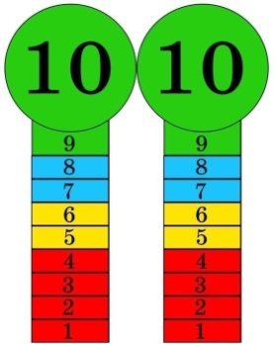  Descriptor:  - read the text  - correct the statements  Total: 1 point  Descriptor:  - read the texts  - find the words  Total: 1 point  Descriptor:  - ask and answer questions  Total: 1 point  -Make CCQ questions Yes / No |   Card  Worksheet  Students book  Chocolate coins  Phones  dictionaries
End of the lesson  5 min | FEEDBACK  Learners provide feedback on what they have learned at the lesson.  Ex:  Home task: ex 4 p 71 and learn 6e module words | 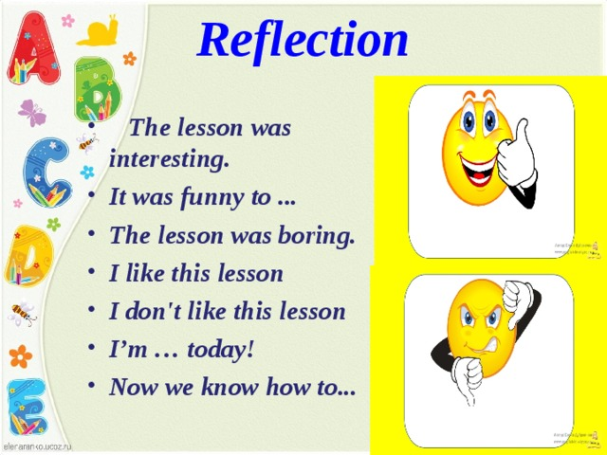 |  | Poster Success  

The ninth of February
Unit 6: The natural world

Slide 1-2. Introduction, Greetings

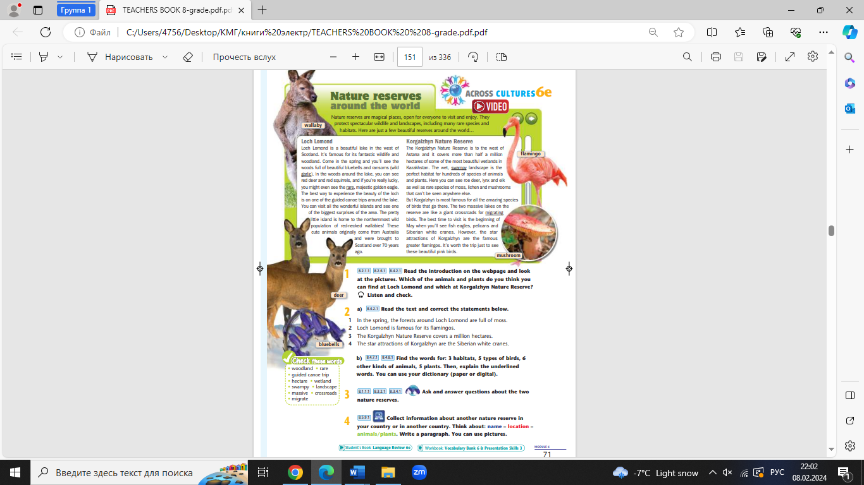
Learning objectives
the text with method Jigsaw

https://www.youtube.com/watch?v=iGRDclS_v1Y
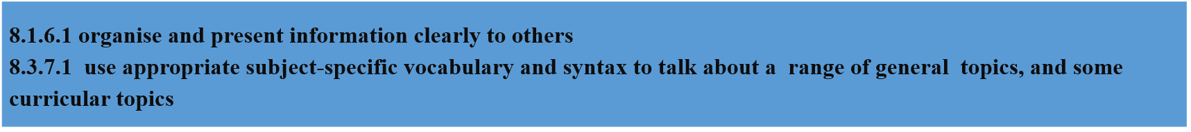

Middle of the lesson Presentation part 30 min

Presentation of new words and play game «who am I»

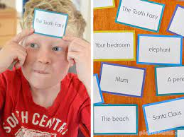

Work with 2 groups

FEEDBACK
Learners provide feedback on what they have learned at the lesson.
Ex:
Home task: ex 4 p 71 and learn 6e module words

